|  |
| --- |
| Project Name |
| High Level Requirements Document |
| **Version n.n** |
| **Date** |

**Project Identification**

|  |  |
| --- | --- |
| **Project:** | GTA Soccer Connect - Team 46 |
| **Prepared By:** | Soroush Salari |
| **Document Version:** | 1.0 |
| **Published Date:** | Sept 23, 2025 |

**Contributors**

*The following individuals contributed to this document.*

| **Name** | **Title** |
| --- | --- |
| Soroush Salari | Technical Requirements Lead |
| Steven Nguyen | Project Vision Lead |
| Laurence Liang | Vision Collaborator & Meeting Manager |
| Kenan Odongo | User Experience Lead |
| Kathan Parikh | Quality Assurance Lead |

**Distribution**

*This document is distributed to all the following people.*

| **Name** | **Title** |
| --- | --- |
| Course Instructor | COMP3059 Instructor |
| Team 46 Members | Development Team |
| Project Stakeholders | Advisory Board |

**Referenced Documents**

*This document refers to the following materials*

|  |  |  |  |  |
| --- | --- | --- | --- | --- |
| **Version number** | **Title** | **Author** | **Date** | **Source / Location** |
| 1.0 | Project Vision Document | Steven Nguyen & Laurence Liang | Sept 2025 | /templates/original/ |
| 1.0 | User Stories and Personas | Kenan Odongo | Sept 2025 | /templates/original/ |
| 1.0 | Project Summary | Steven Nguyen | Sept 2025 | /templates/original/ |

**Revision History**

|  |  |  |  |
| --- | --- | --- | --- |
| **Version Number** | **Revision Date** | **Summary of Changes** | **Modified by** |
| 0.1 | Sept 20, 2025 | Initial Draft | Soroush Salari |
| 0.5 | Sept 22, 2025 | Added functional requirements | Soroush Salari |
| 1.0 | Sept 23, 2025 | Final version with all requirements | Soroush Salari |

*[Note: It is recommended that drafts be numbered 0.1 to 0.9, and that the first approved version be numbered 1.0. Thereafter, new version numbers will depend upon changes: 1.01, 1.1, etc for minor updates, 2.0, 3.0 etc for major changes.]*

**TABLE OF CONTENTS**

***1.*** ***BUSINESS CONTEXT DIAGRAM 3***

***2.*** ***REQUIREMENTS SCOPE STATEMENTS 4***

***3.*** ***HIGH LEVEL BUSINESS REQUIREMENTS SIGN-OFF 5***

1. **Business Context Diagram**

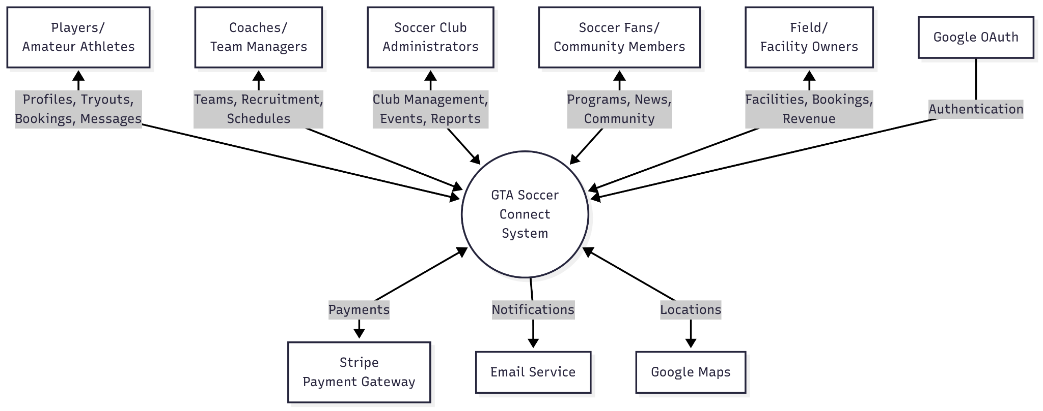

|  |  |
| --- | --- |
| **Requirement Scope Area** | **Description** |
| GTA Soccer Connect Platform | Comprehensive soccer community platform connecting players, teams, facilities, and fans across the Greater Toronto Area |

|  |  |
| --- | --- |
| **External Entity** | **Description** |
| Amateur/Semi-Pro/Pro Players | Individual users seeking teams, tryouts, and playing opportunities |
| Team Coaches/Managers | Users responsible for team operations, recruitment, and management |
| Soccer Club Administrators | Users managing multiple teams, events, and club operations |
| Soccer Fans/Community Members | Users following teams, finding programs, and engaging with community |
| Field/Facility Owners | Users managing facility bookings, pricing, and maintenance |
| Payment Gateway Systems | External services for processing payments (Stripe, PayPal) |
| Location Services | External mapping and location APIs (Google Maps) |
| Social Media Platforms | External platforms for sharing and authentication |

| **Information Flows** | **Description** |
| --- | --- |
| Player Registration Data | User profiles, skills, experience, availability flowing into system |
| Tryout Postings | Team requirements and tryout details from coaches to players |
| Booking Requests | Field reservation requests from users to facility owners |
| Payment Transactions | Financial data flowing between users and payment gateway |
| Location Data | GPS coordinates and mapping data for field locations |
| Chat Messages | Real-time communication between system users |
| Event Notifications | System alerts about tryouts, bookings, and updates |
| Performance Analytics | Player statistics and team performance data |

1. **Requirements Scope Statements**

|  |  |  |
| --- | --- | --- |
| **HLR#** | **Description** | **Priority**  **(H, M, L)** |
| HLR-001 | User registration and authentication system with role-based access (Player, Coach, Admin, Fan, Facility Owner) | H |
| HLR-002 | Comprehensive player profile system with stats, photos, videos, and skill showcases | H |
| HLR-003 | Tryout board for posting, discovering, and registering for team tryouts | H |
| HLR-004 | Field/facility booking system with real-time availability and payment processing | H |
| HLR-005 | Real-time messaging and chat system for individuals and groups | H |
| HLR-006 | Advanced search and filtering for players, teams, tryouts, and facilities | H |
| HLR-007 | Team management dashboard for rosters, schedules, and communications | H |
| HLR-008 | Payment processing for field bookings, registrations, and membership fees | H |
| HLR-009 | Event management system for tournaments, leagues, and community events | M |
| HLR-010 | Email notifications for tryouts, bookings, and updates | M |
| HLR-011 | Social features including team following and news feeds | M |
| HLR-012 | Staff/job marketplace for coaches and support personnel | M |
| HLR-013 | Youth program discovery and family-friendly activity finder | M |
| HLR-014 | Performance tracking and analytics for players and teams | L |
| HLR-015 | Community forums and discussion boards | L |
| HLR-016 | All user data must be encrypted | H |
| HLR-017 | HTTPS/SSL for all data transmissions | H |
| HLR-018 | Responsive web design supporting all modern browsers | H |
| HLR-019 | Multi-language support (English and French) | M |

1. **High Level Business Requirements Sign-Off**

*The undersigned acknowledge their agreement with the contents of Version 1.0 of the* High-Level *Requirements document for* **GTA Soccer Connect - Team 46**.

*Following approval of this document, requirements changes will be governed by the project’s change management process, including impact analysis and appropriate reviews and approvals, under the general control of the Project Plan and according to company policy. Approved Change Request Documents, if present, will be attached to this Requirements Document as updates.*

|  |  |  |
| --- | --- | --- |
| **Name** | **Project Role and**  **Functional Area** | **Date Signed** |
| Soroush Salari | Technical Requirements Lead | September 23, 2025 |
| Steven Nguyen | Project Vision Lead | September 28, 2025 |
| Laurence Liang | Vision Collaborator & Meeting Manager | September 28, 2025 |
| Kenan Odongo | User Experience Lead | September 28, 2025 |
| Kathan Parikh | Quality Assurance Lead | September 28, 2025 |
| Course Instructor | Project Supervisor | September 28, 2025 |

*\* Note: physical signatures are not required. Email approvals are acceptable and should be appended to project documents.*